Before proceeding with the project, kindly fill out the feedback form for week 1 below:

https://forms.office.com/r/4F2xy5HvPY

Do not hesitate in sharing what you liked the most and what you think can be done to improve your learning experience.

Project 01

Objectives:
- Create and manage Docker volumes for data persistence.
- Set up a Docker network for container communication.
- Use Docker Compose to manage multi-container applications.
- View and manage Docker logs.
- Deploy the application using Docker Swarm.

Project Outline:
- Create Docker Volumes
- Create a Docker Network
- Write a Docker Compose File
- Deploy the Application with Docker Compose
- Manage Docker Logs
- Deploy the Application Using Docker Swarm

Step-by-Step Guide

1. Create Docker Volumes
Docker volumes are used to persist data generated by and used by Docker containers.
docker volume create wordpress_data
docker volume create mysql_data
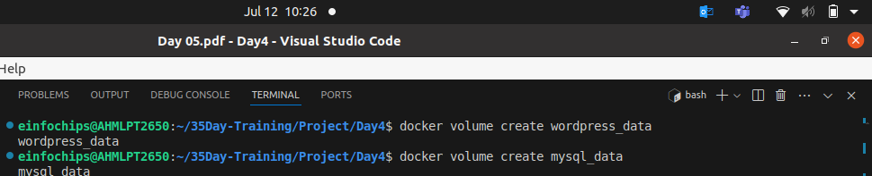

2. Create a Docker Network
Create a custom network for the containers to communicate.
docker network create wordpress_network
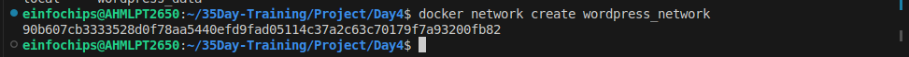

3. Write a Docker Compose File
Create a docker-compose.yml file to define and manage the services.
version: '3.3'

services:
db:
image: mysql:5.7
volumes:
- mysql_data:/var/lib/mysql
networks:
- wordpress_network
environment:
MYSQL_ROOT_PASSWORD: example
MYSQL_DATABASE: wordpress
MYSQL_USER: wordpress
MYSQL_PASSWORD: wordpress

wordpress:
image: wordpress:latest
volumes:
- wordpress_data:/var/www/html
networks:
- wordpress_network
ports:
- "8000:80"
environment:
WORDPRESS_DB_HOST: db:3306
WORDPRESS_DB_USER: wordpress
WORDPRESS_DB_PASSWORD: wordpress
WORDPRESS_DB_NAME: wordpress

volumes:
mysql_data:
wordpress_data:

networks:
wordpress_network:

4. Deploy the Application with Docker Compose
Run the following command to start the services defined in the docker-compose.yml file.
docker-compose up -d

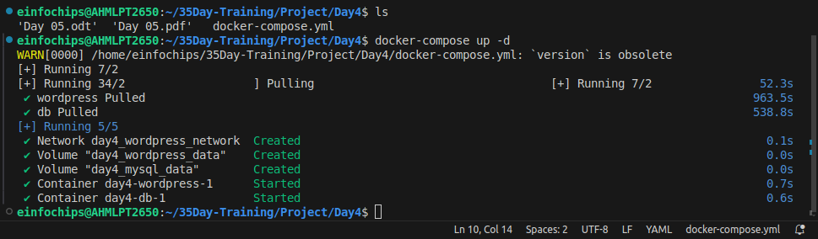
- Verify that the containers are running.
docker-compose ps
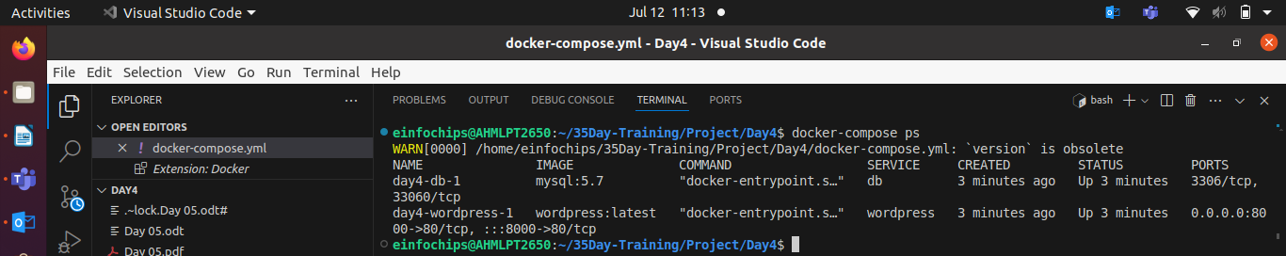
- Access the WordPress setup by navigating to http://localhost:8000.
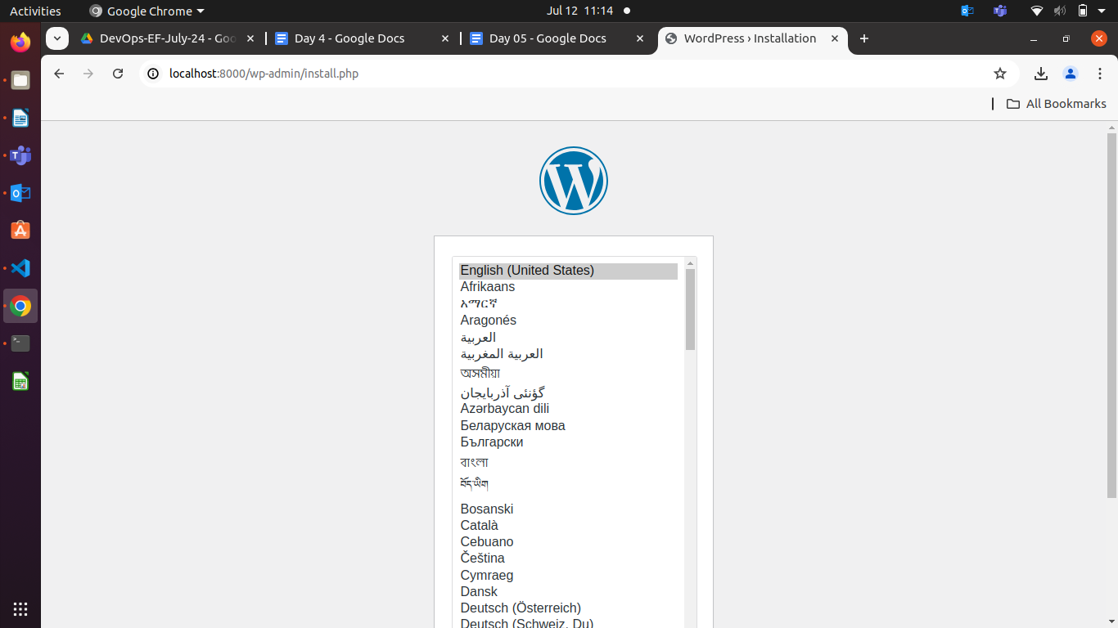

5. Manage Docker Logs
- View logs for a specific service.
docker-compose logs wordpress
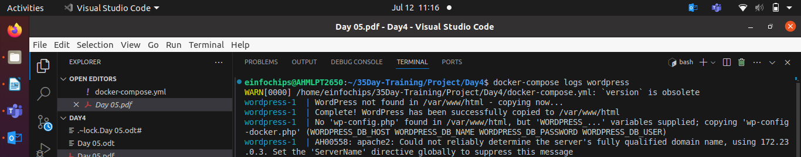
- Follow logs for real-time updates.
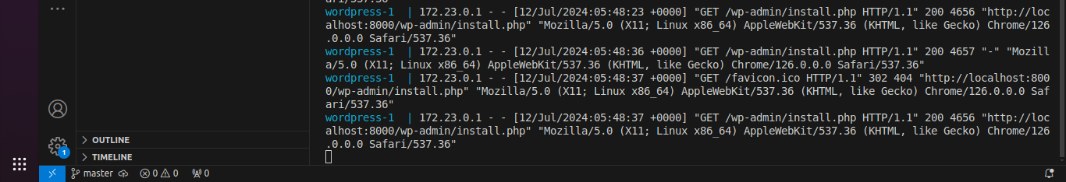
docker-compose logs -f wordpress

6. Deploy the Application Using Docker Swarm
Docker Swarm is a native clustering and orchestration tool for Docker.
- Initialize Docker Swarm.
docker swarm init

- Convert the Docker Compose file to a Docker Stack file, docker-stack.yml.
version: '3.3'

services:
db:
image: mysql:5.7
volumes:
- mysql_data:/var/lib/mysql
networks:
- wordpress_network
environment:
MYSQL_ROOT_PASSWORD: example
MYSQL_DATABASE: wordpress
MYSQL_USER: wordpress
MYSQL_PASSWORD: wordpress
deploy:
replicas: 1

wordpress:
image: wordpress:latest
volumes:
- wordpress_data:/var/www/html
networks:
- wordpress_network
ports:
- "8000:80"
environment:
WORDPRESS_DB_HOST: db:3306
WORDPRESS_DB_USER: wordpress
WORDPRESS_DB_PASSWORD: wordpress
WORDPRESS_DB_NAME: wordpress
deploy:
replicas: 1

volumes:
mysql_data:
wordpress_data:

networks:
wordpress_network:

- Deploy the stack using Docker Swarm.
docker stack deploy -c docker-stack.yml wordpress_stack

- Verify the stack is running.

docker stack services wordpress_stack
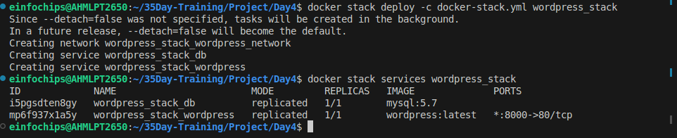

Project 02:

Objectives:
- Deploy an application across multiple Docker Swarm worker nodes.
- Place specific components on designated nodes.
- Monitor and troubleshoot using Docker logs.
- Modify and redeploy the application.

Project Outline:
- Initialize Docker Swarm and Join Worker Nodes
- Label Nodes for Specific Component Placement
- Create a Docker Stack File
- Deploy the Application
- Monitor and Troubleshoot Using Docker Logs
- Modify and Redeploy the Application

Step-by-Step Guide

1. Initialize Docker Swarm and Join Worker Nodes
On the manager node, initialize Docker Swarm:
docker swarm init --advertise-addr <MANAGER-IP>

Join the worker nodes to the swarm. On each worker node, run the command provided by the docker swarm init output:
docker swarm join --token <SWARM-TOKEN> <MANAGER-IP>:2377
Verify the nodes have joined:
docker node ls
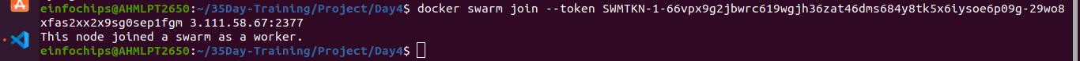

2. Label Nodes for Specific Component Placement
Label nodes to specify where certain components should run. For example, label a node for the database service:
docker node update --label-add db=true <NODE-ID>
Before update label , default label is ..
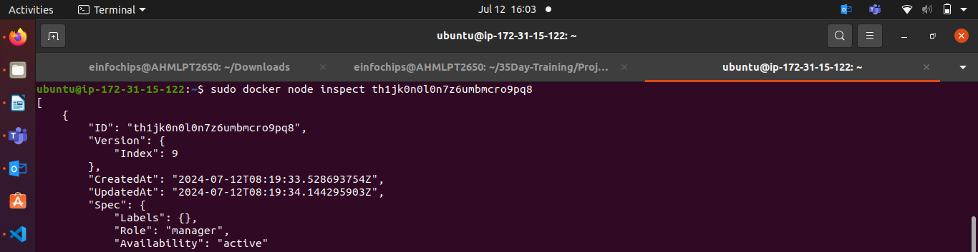
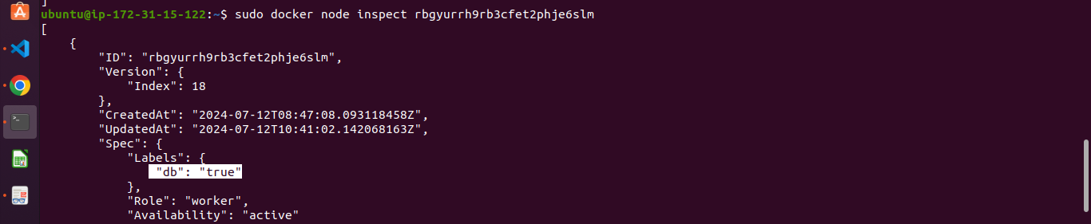

Label another node for the application service:
docker node update --label-add app=true <NODE-ID>
For worker node default label is
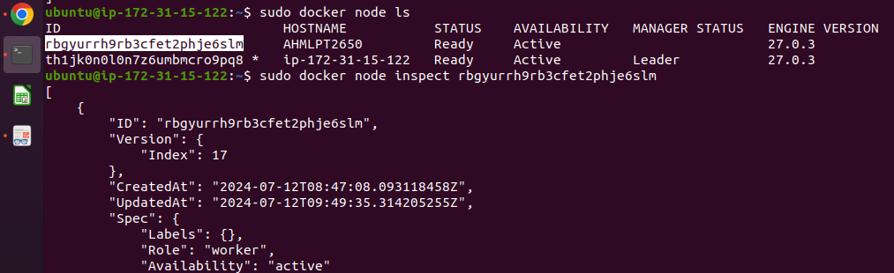
Verify the labels:
docker node inspect <NODE-ID>
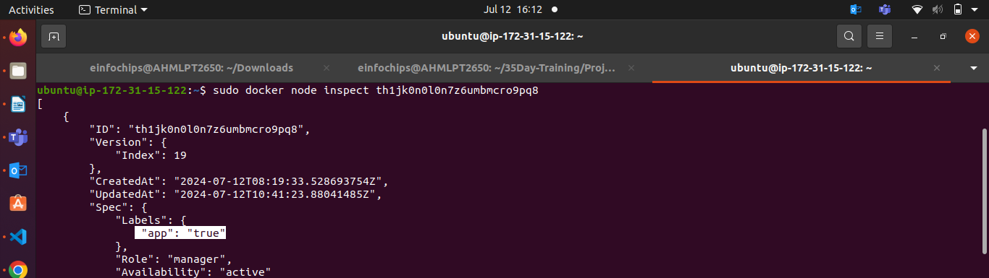

3. Create a Docker Stack File
Create a docker-stack.yml file to define the services and node placement constraints:
version: '3.8'

services:
db:
image: mysql:5.7
volumes:
- mysql_data:/var/lib/mysql
networks:
- app_network
environment:
MYSQL_ROOT_PASSWORD: example
MYSQL_DATABASE: appdb
MYSQL_USER: user
MYSQL_PASSWORD: password
deploy:
placement:
constraints:
- node.labels.db == true

app:
image: your-app-image
networks:
- app_network
ports:
- "8000:80"
environment:
DB_HOST: db
deploy:
replicas: 2
placement:
constraints:
- node.labels.app == true
volumes:
mysql_data:
networks:
app_network:

4. Deploy the Application
Deploy the stack using Docker Swarm:
docker stack deploy -c docker-stack.yml app_stack

docker stack services app_stack

5. Monitor and Troubleshoot Using Docker Logs
Check the logs for the services:
docker service logs app_stack_db
docker service logs app_stack_app

Follow the logs in real-time to monitor issues:
docker service logs -f app_stack_app
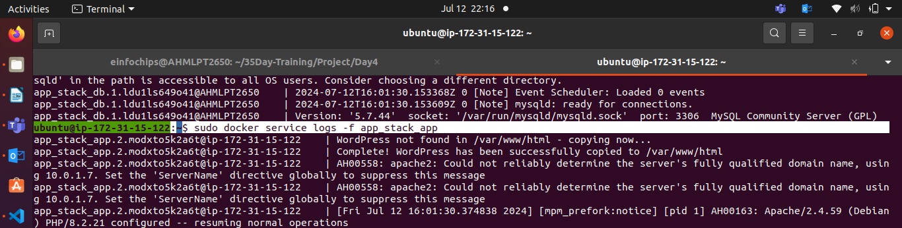

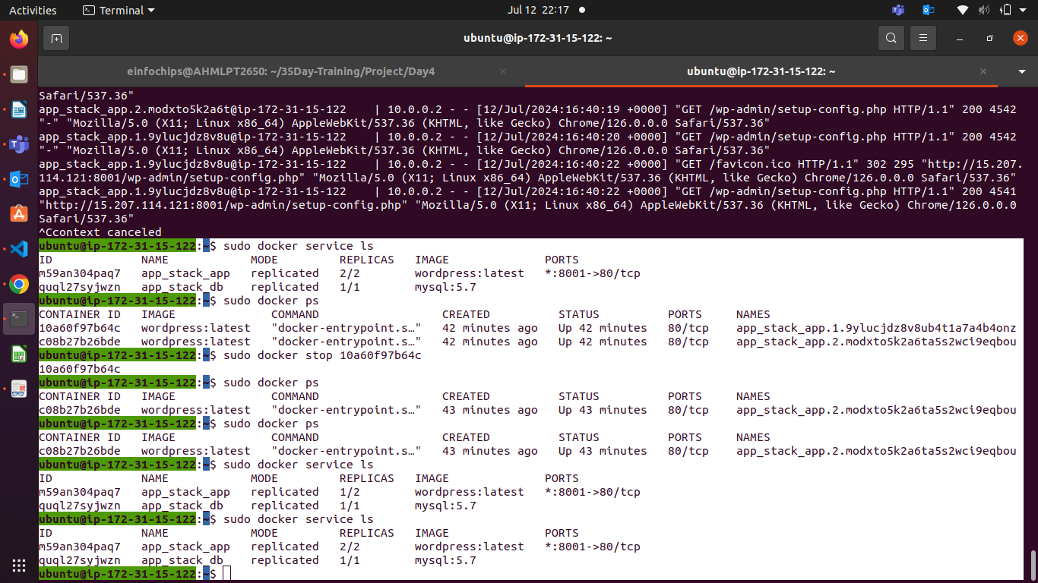
If Your master node is ec2 where your web is wordpress is running,
So, you have to create SG & allows ports like below,

You have to allow traffic from Master node port 2277 ,
Port from where your web app is publically expose by docker-compose file – 8081 .
Bcz, if your port is dydefault , your SG will allow port 80 traffic.
Like that, if your port is 8081 , you should allow traffic to this port 8081 from SG.
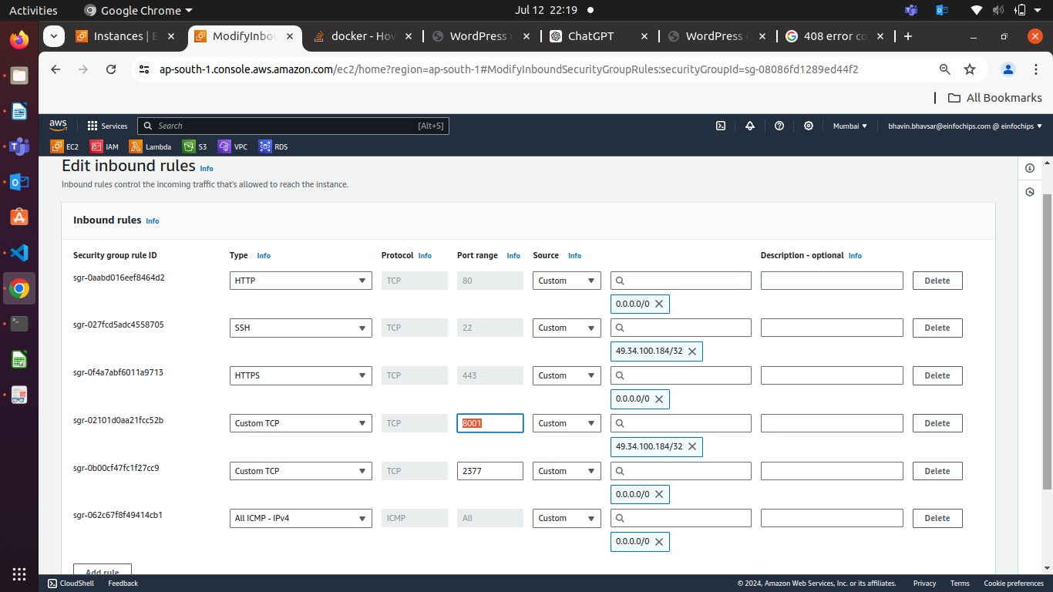

6. Modify and Redeploy the Application
Make modifications to the application or the stack file as needed. For example, change the number of replicas:
services:
app:
deploy:
replicas: 3

Update the stack with the new configuration:
docker stack deploy -c docker-stack.yml app_stack

Verify the changes:
docker stack services app_stack
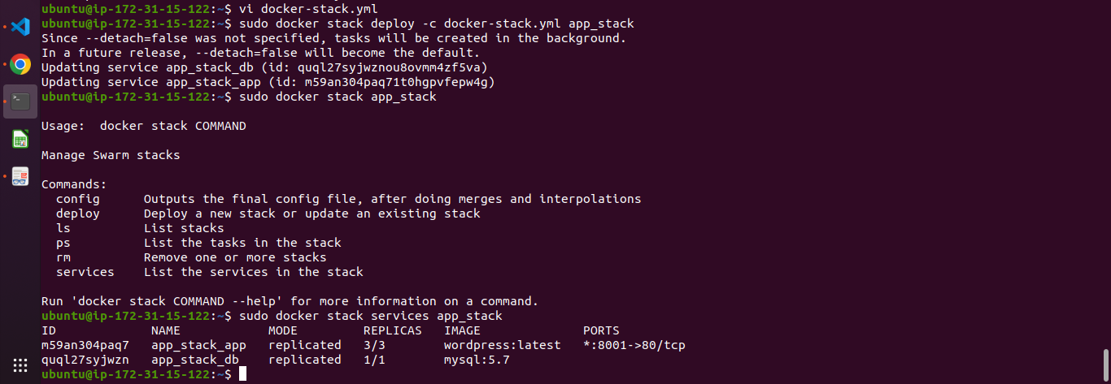

Search ec2_instance_public_ip:8081/
